
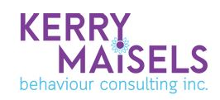

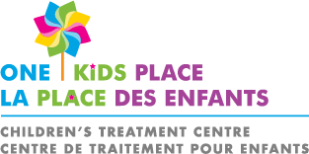

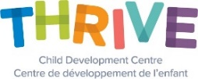


Caregiver Mediated Early Years - Project ImPACT

What is Project ImPACT?
Project ImPACT is an evidence-based parent-mediated intervention program based on best practices in early intervention.
- Teaches core social communication skills in a developmental framework
- Uses a blend of developmental and ABA teaching strategies within play and daily caregiving routines
- Uses eﬀective parent coaching and engagement strategies to help parents learn and use the intervention
- Includes elements to support community use, including detailed procedures, family-friendly materials, and two ﬂexible delivery models
Who is Project ImPACT for?
For families/caregivers that have received a Ministry invitation to participate in this program.
For children who are 12 – 48 months of age and are registered with the Ontario Autism Program and meet the eligibility criteria for the Ontario Autism Program: Caregiver-Mediated Early Years Programs.
How was Project ImPACT developed?
Project ImPACT is the result of over 15 years of research and development. The developers worked together with families, providers, administrators, and experts to ensure that Project ImPACT can be used effectively in a variety of community intervention programs.
Who can deliver Project ImPACT?
A variety of early intervention professionals - including speech therapists, BCBAs, special educators, social workers, psychologists, and occupational therapists - can coach families effectively in Project ImPACT.
What can Families expect?
Project ImPACT is a 12-week program that can be delivered as an individual or group coaching model. In both models, sessions focus on helping parents learn strategies to teach their child new social communication skills and manage their child’s behavior.
- Individual coaching model: The parent, child, and coach meet once or twice a week for 60–90-minute sessions for 12 weeks
- Group coaching model: The parent attends six 2-hour parent-only group sessions and meets with the child and coach for six 1-hour individual coaching sessions. Group and individual sessions alternate weekly for 12 weeks
- The coach and parent work together to set child goals, learn and practice strategies, and problem solve
- Between sessions, parents practice what they learn to teach their child new skills


What are the benefits of Project ImPACT?
- Children get many more hours of learning and practice, which improves their social communication
- Children learn in meaningful activities, which helps them use skills in new situations and over time
- Parents feel more conﬁdent supporting their child’s development
- Parents experience less stress and have more positive parent-child interactions
To register or find out more information, please contact Kim Einarson, Supervisor, Regional Services, Child & Community Resources by telephone 1-877-996-1599 extension 2608 or by email keinarson@ccrconnect.ca
Or speak with a Project ImPACT Coach from one of the partnering agencies:

FIREFLY George Jeffrey Children’s Centre Kerry Maisels
http://www.fireflynw.ca/ http://www.georgejeffrey.com/ https://www.kerrymaisels.com/

THRIVE Child Development Centre One Kids Place Children’s Treatment Sioux Lookout First Nations
https://kidsthrive.ca/ Centre Health Authority
https://www.onekidsplace.ca/ https://www.slfnha.com/

