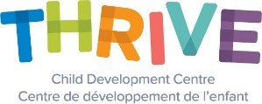
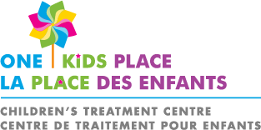

Caregiver Mediated Early Years - Pivotal Response Training (PRT)

What is Pivotal Response Training?
A naturalistic developmental behavioural play-based intervention for children who are able to make some identifiable speech sounds; for children with limited or more advanced vocal communication.

Who is Pivotal Response Training for?
For families/caregivers who want to:
- Learn strategies to help motivate their child’s learning, play, communication, engagement, and social interactions;
- Teach their child how to communicate;
- Feel empowered to motivate their child to engage with others and initiate interactions; and
- Benefit from learning the core strategies of PRT to support their child’s development

Eligibility:
- Children who are registered with the Ontario Autism Program (OAP) and meet the eligibility criteria for the OAP: Caregiver-Mediated Early Years Programs : 12 to 48 months of age and have received an invitation letter from the Ministry of Children, Community and Social Services
- Children who are diagnosed with Autism Spectrum Disorder who exhibit difficulty with social engagement and have significant language delays

To register or find out more information, please contact Kim Einarson, Supervisor, Regional Services, Child & Community Resources by telephone 1-877-996-1599 extension 2608 or by email keinarson@ccrconnect.ca
Or speak with a Pivotal Response Therapist from one of the partnering agencies:
FIREFLY George Jeffrey Children’s Centre
http://www.fireflynw.ca/ http://www.georgejeffrey.com/

THRIVE Child Development One Kids Place Children’s ABA Northern Services & Training
Centre Treatment Centre https://www.facebook.com/abanorthernservices/
https://kidsthrive.ca/ https://www.onekidsplace.ca/

What is the program commitment?
12-week program consisting of 2 group sessions, and 9-1 hour individual coaching sessions with a PRT therapist.

Why consider PRT and What are the benefits?
PRT learning objectives for caregivers:
- Demonstrating shared control in interactions with the child
- Setting up opportunities for the child to respond
- Interspersing easy and new tasks throughout the day
- Providing natural and contingent reinforcement
- Reinforcing language attempts
PRT learning objectives for the child:
- Motivation to learn, play, and communicate
- Communicating using first words
- Expanding from single words to multiple word utterances
- Responding to multiple cues in the environment
- Initiating social interactions

Where is the service offered?
- Virtual sessions from the comfort of your own home with the opportunity for in-person individual coaching sessions depending on location
- Within the child’s natural environment during everyday routines, play and naturally occurring daily activities

Who Delivers the Intervention?
PRT is supervised by a BCBA or Psychologist and delivered by PRT therapists with experience implementing ABA programs for children with ASD and training caregivers using Behavioural Skills Training (BST)

